

**Bangladesh University of Business & Technology (BUBT)**

Department of Computer Science & Engineering (CSE)

**Project Report**

On

Voice Controlled and Obstacle Avoider Robotic Vehicle

**Under the Guidance of**

Abdullah Al Ahasan

Lecturer Of

Department of CSE



**Project Report Submitted By**

Name ID

1. Rabeya Siddika Sajia 14151103062
2. Irfat Jahan Ananna 14151103071
3. Sajeda Akter Shorna 14151103085

**Title of the Project:** Voice Controlled and Obstacle Avoider Robotic Vehicle.

Date of Submission: 22.01.2017

**Abstract**

**This paper presents a robotic vehicle that can be conducted by the voice or speech commands given from the user. However, interacting with electronic devices using speech is the most unique way of interaction and communication for human beings.**

**Here, we pass commands to the robotic vehicle with the help of android device which transmits voice commands to an Arduino to achieve this functionality.**

**Keywords – Robotic, Speech, Interaction, Arduino.**

I. Introduction

Nowadays robots are essential in many manufacturing industries. The reason is that the expenditure per hour to conduct a robot is a fraction of the cost of the human activity needed to perform the same work. More than this, once they are programmed, robots continuously perform functions with a high accuracy that beats the most experienced humans. However, humans are far more versatile. They can change job tasks easily.[1-4] On the other hand, robots are made and programmed to do specific type of job. We wouldn’t be able to program a welding robot to start counting parts in a bin. Robots are in the babyhood stage of their evolution. As robots evolve, they will become more versatile, emulating the human scope and ability to switch job tasks quickly. While the personal computer has made an unforgettable mark on society, the personal robot hasn’t made an presence. Obviously there’s more to a personal robot than a personal computer. Robots need a combination of elements to be efficient: sophistication of intelligence, movement, mobility, navigation, and purpose.

Voice Controlled Robotic Vehicle is a robot whose gestures can be controlled by the user by providing specific voice commands to it. The speech recognition is capable of diagnosing the 5 voice commands „Forward‟, „Stop‟, „Left‟, ‟Right‟ and „Backward‟ issued by a particular user. It can also automatically stop when it senses an Obstacle in front of it. We are aiming at is to control the robot using following voice commands.

Robot can do these basic tasks:

1. Moving Forward
2. Moving Backward
3. Turning Left
4. Turning Right
5. Stop (also stops automatically if it senses an Obstacle or if wrong instruction is given)

The speech recognition is a speaker dependant. The special feature of the application understands the speech module, to train itself for the above voice commands for a specific user. [5-7]

II. Structure and Design of the Robotic Vehicle

The Hardware part of the Robotic Vehicle consists of the following parts.

1. Arduino Uno R3
2. L293D Motor Shield for Arduino
3. HC-SR04 Ultrasonic Sensor
4. LM35DZ Temperature Sensor
5. HC-05 Serial Port Bluetooth
6. MB-102 Solder Less Bread board
7. Male-Male and Male-Female Jumper Wires
8. Base Board
9. Robot Wheel (2 Pieces)
10. Deceleration DC motor (2 Pieces)
11. Hammer caster
12. Switch
13. Encoder Disc (2 Pieces)
14. Screws, Nuts, L12 Spacer bars and Fastener

Tools Required:

1. Soldering Iron
2. Screw Driver

III. Speech Recognition

The technique of a machine’s listening to voice or speech and understanding the words is called Speech Recognition System. It is an ideal form for robotic control and communication. The speech recognition circuit we will blueprint, functions freely form the robot’s main intelligence (CPU). This is a good concept because it doesn’t take any of the robots main CPU processing potential for word recognition. The CPU must simply survey the speech circuit’s recognition lines hardly to check if a command has been delivered to the robot.

We can even develop upon this by joining the recognition line to one of the robot’s CPU interrupt lines. By doing this, a recognized word would cause an interrupt, letting the CPU know a recognized word had been uttered. The advantage of using an interrupt is that polling the circuit’s recognition border sometimes would no longer be essential, further reducing any CPU overhead.

Another benefit to this stand-alone speech recognition circuit (SRC) is its programmability. You can train and program the SRC to recognize the exclusive words you want to remember. The SRC can be easily interfaced to the robot’s CPU. To control an appliance like computer, VCR etc, by speaking to it, will make it easier, while increasing the efficiency and effectiveness of working with that equipment. At its most basic level speech recognition allows the user to perform aligned tasks, while continuing to work with the computer or appliance.

IV. Hardware Components

A. Arduino Uno R3

Arduino Uno is a microcontroller board. It is based on the ATmega328P. It has 6 analog inputs, 14 digital input/output pins, one 16 MHz quartz crystal, a USB connection, one power jack, one reset button and an ICSP header. [8] The Uno board and version 1.0 of Arduino Software (IDE) were the allusion version of Arduino, now expanded to newer releases. It contains everything required to support the microcontroller; simply connect it to a computer with a USB cable or power it with one AC-to-DC adapter or battery to start it. We can mess with our UNO without being concerned too much about doing any mistake. The Uno board is the first in a series of USB Arduino boards, and the allusion model for the Arduino platform; for a comprehensive list of current, past or out-of-date boards see the Arduino index of boards.

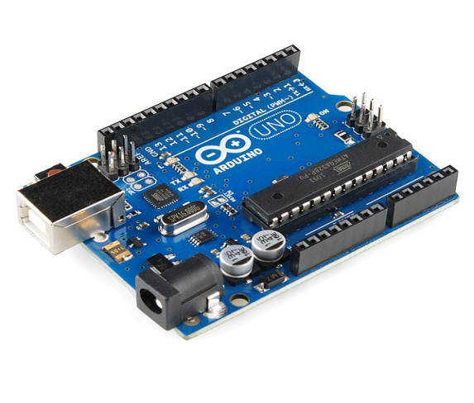

Fig. 4.1: Arduino Uno R3

B. L298N Dual Motor Controller Module

L298N H-bridge Dual Motor Controller Module 2A with Arduino allows controlling the speed and direction of two DC motors, or controlling one bipolar stepper motor with ease. The L298N H-bridge module can be implemented on motors that have a voltage of between 5 and 35V DC. There is also an onboard 5V regulator, so if your supply voltage is up to 12V you can also source 5V from the board.

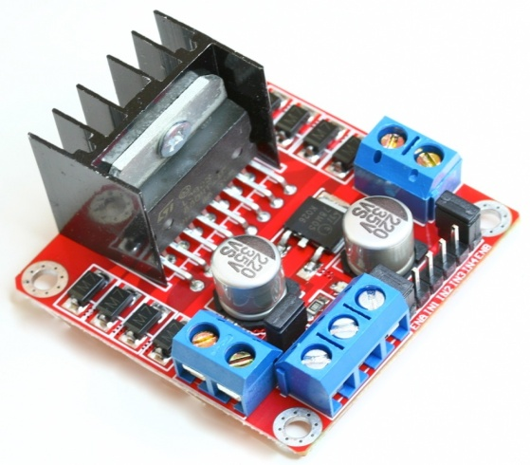

Fig. 4.2: L298N Dual Motor Controller

C. HC-SR04 Ultrasonic Sensor

The HC-SR04 Ultrasonic sensors determine the distance between themselves and the nearest obstacle by transmitting an ultrasound pulse and timing how long it takes for that pulse to be mirrored off the nearest obstacle and return to the sensor.[10] They are easy to use, accurate, and they can be very cheap. It offers excellent non-contact range disclosure with high accuracy and strong readings in an easy to use packet. Its activity is not afflicted by sunlight or black material like Sharp rangefinders, although acoustically soft materials like cloth can be hard to detect. But they cannot detect smooth objects, so soft or uneven surfaces. Most kinds of fabric are mostly invisible to an ultrasonic sensor.

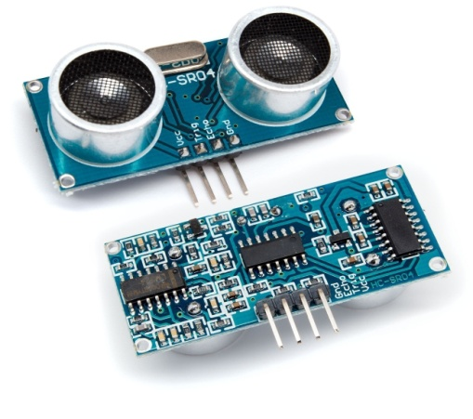

Fig. 4.3: HC-SR04 Ultrasonic Sensor

D. HC-05 Serial Port Bluetooth

HC-05 Serial Port Bluetooth module is an easy to use Bluetooth SPP (Serial Port Protocol) module, constructed for transparent wireless serial connection setup. Serial port Bluetooth module is fully certified Bluetooth V2.0+EDR (Enhanced Data Rate) 3Mbps Modulation with complete 2.4GHz radio transceiver and baseband.[9] It uses CSR Blue core 04-External single chip Bluetooth structure with CMOS machinery and with AFH(Adaptive Frequency Hopping Feature). It has the footprint as tiny as 12.7mmx27mm.

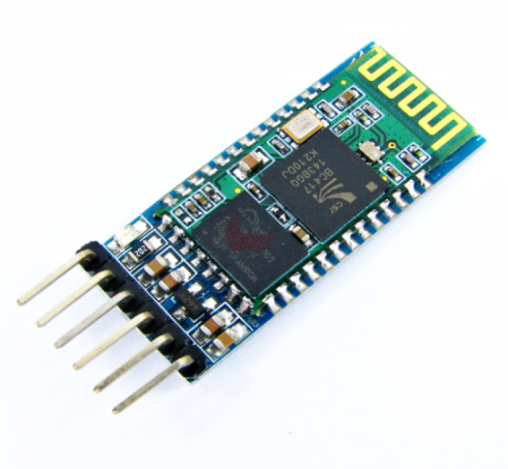

Fig. 4.4: HC-05 Serial Port Bluetooth

E.DC Motor

Dual shaft DC geared motor which allows good torque and rpm at lower voltages. Electric machines are means of converting energy. Motors take electrical energy and produce mechanical energy. This DC motor can run at approximately 375 rpm when compelled by a single Li-Ion cell. It is most applicable for light weight robot running on small voltage. Out of its two shafts one shaft can be associated to wheel, other can be associated to the position encoder.

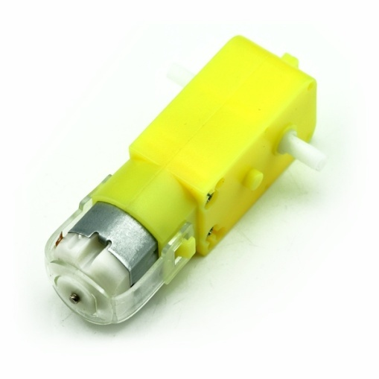

Fig. 4.5: DC Motor

V. Block Diagram

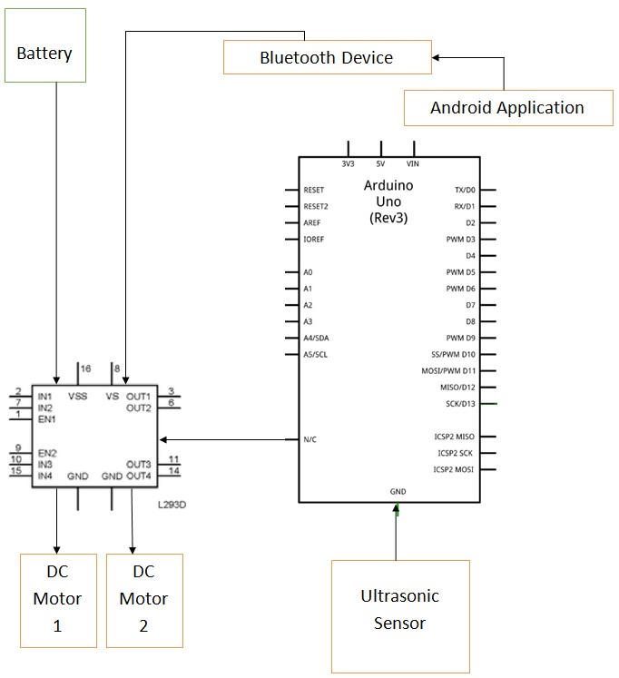

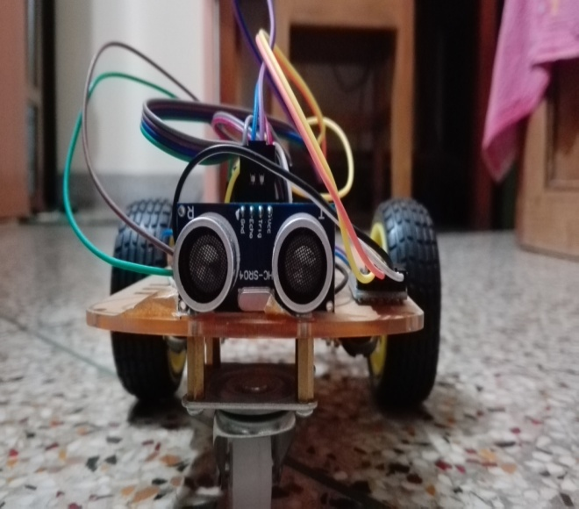

Fig.5.1: Front picture of robot

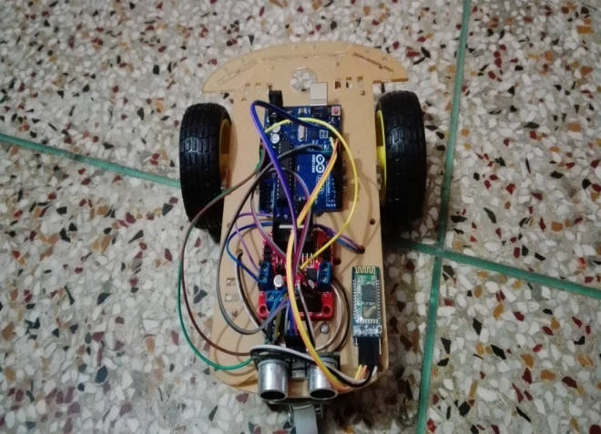

Fig. 5.2: Upper part of robot

VI. Implementation

In this system, an android application is used to detect and process human voice which is further converted into text. This text is transferred to the robot using Bluetooth. This text is further processed by the arduino to control the robot accordingly.

For this we need to download an app named “voicebot” from the Google play store and then install it.

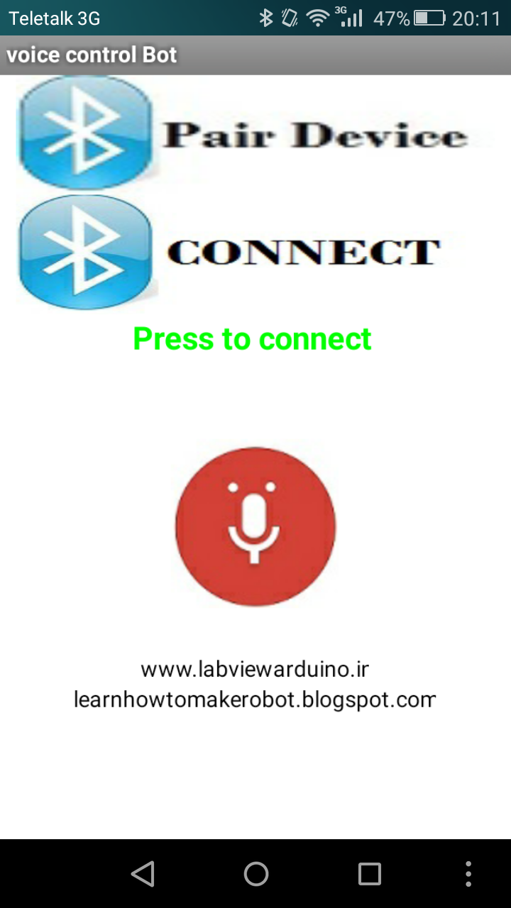

Fig.6.1: Installed App

Then we have to press “CONNECT” and connect the app with HC-05 Bluetooth module of the robot.

Then we give to command to the robot. When we speak “FORWARD” our speech gets recognized and converted into text. That text is transferred to robot through Bluetooth. The robot receives the string, decodes it and compares it with the strings (Instructions) that are described in the program and moves the robot in forward direction.

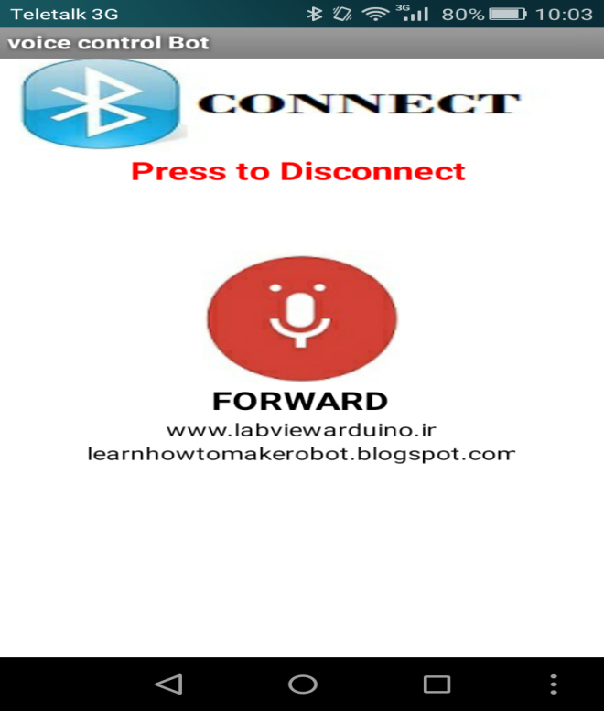

Fig.6.2: Giving command ‘Forward’

In the same way back, right, left and stop commands are given. Even when any wrong command is given it automatically stops without giving ‘stop’ command.

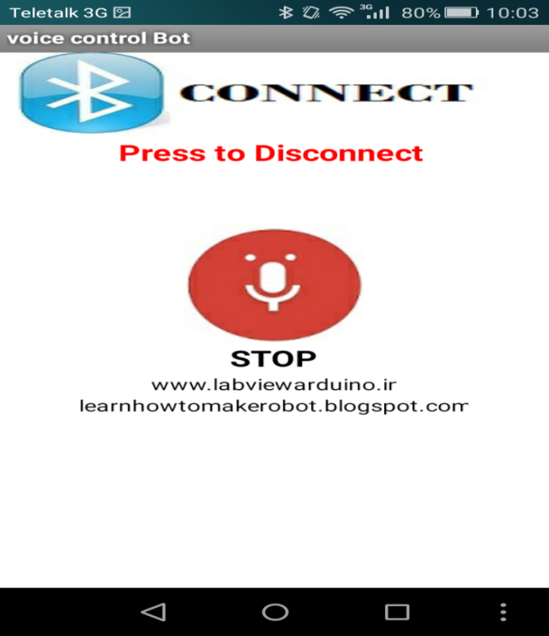

Fig.6.3: Giving command ‘Stop’

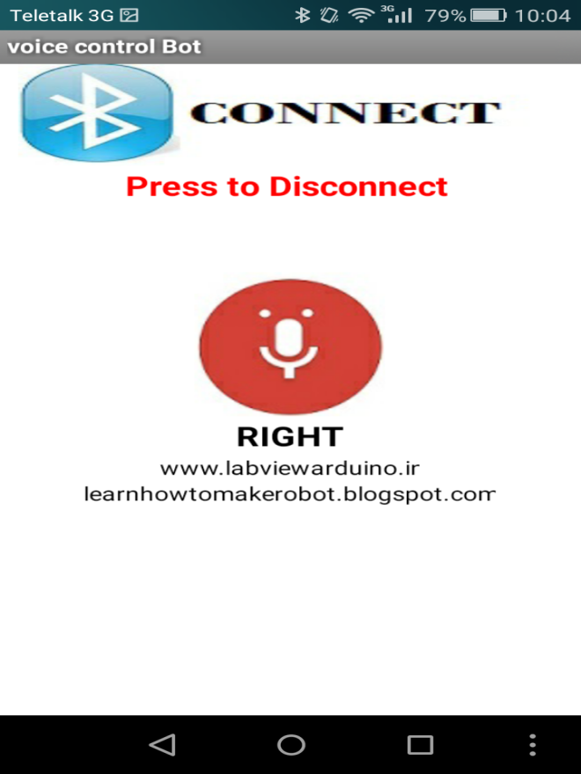

Fig.6.4: Giving command ‘Right’

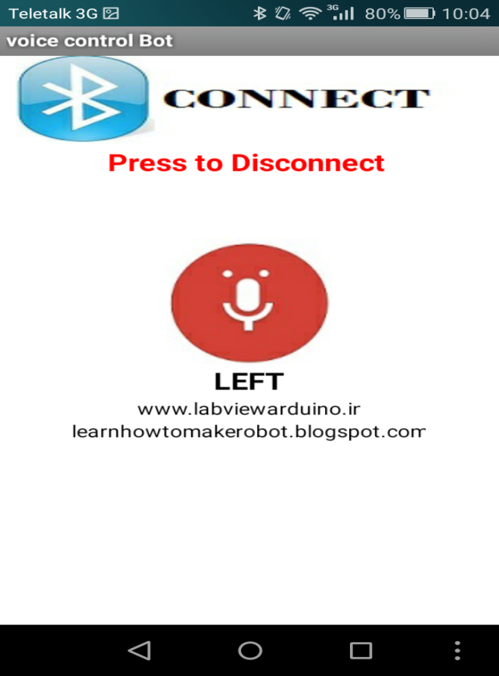

Fig.6.5: Giving command ‘Left’

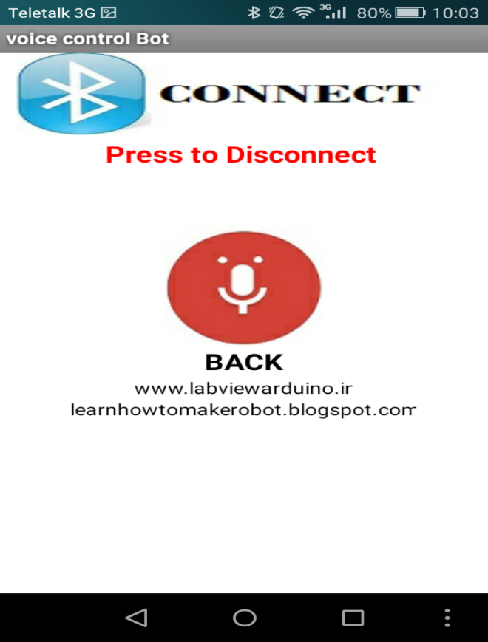

Fig.6.6: Giving command ‘Back’

VII. Algorithm

1. The voice commands which will be given are clearly written in the code.
2. At first, the android app will be connected with Bluetooth module.
3. Then, the commands are passed through the app to the Bluetooth module and it checks with the code in the arduino.
4. If it matches then the robot starts moving according to the instructions provided.

VIII. Result & Discussion

Results show that it is absolutely possible for a user to learn to efficiently manipulate real world matters with only voice as a control mechanism. The proposed results provide firm evidence that the additional development of voice controlled robotics will be successful. This system would find wide range of applications.. In such case this research will work out practically satisfying the need of the day efficiently.

IX. Future Work

This project can be further implemented with Microcontroller instead of arduino. This system also can be advanced by using GSM technology. The knowledge is ever growing and so are the problems which the mankind tackles to solve. In this spirit, it is hoped that the present activity will lead to further enhancements.

X. Conclusion

Wireless control is one of the most important needs for all living beings. But sadly due to a huge amount of data and communication overheads the technology is not fully utilized.

The voice-controlled robot designed can be viewed as a model of Auto control. It could be widely used in many automated control systems if ongoing to improve its function. When making some small changes, it could be used to control air-conditioner, video recorders and other electrical appliances.

Acknowledgement

We would like to thank and acknowledge and extend our heartfelt gratitude to all those people who have been associated with this project and have helped us with it thus making it a worthwhile experience especially the support and guidance given by our teacher, Abdullah Al Ahasan for this project.

References

[1] LX. L. Zhou, Z.Y. Sun, Z. Y. Liu, Y. Q. Chen, D. Y. Peng, F. M. Guo*, Z. Q. Zhu School of Information Science & Technology, East China normal University Shanghai, “Embedded Vehicle Control System Based on Voice Processing Technologies” Proceedings of the 2008 IEEE/ASME International Conference on Advanced Intelligent Mechatronics.

[2] Lebe` gue X, Aggarwal JK. “Generation of architectural CAD models using a mobile robot”. Proceedings of 1994 IEEE International Conference on Robotics and Automation, San Diego, California, USA, Vol. 1. May 1994.

[3] Nashashibi F, Devy M, Fillatreau P. “Indoor scene terrainmodeling using multiple range images for autonomous mobile robots”. Proceedings of 1992 IEEE International Conference on Robotics and Automation, Nice, France, Vol. 1. May 1992.

[4] Nashashibi F,Devy. “M.3D incremental modeling and robot localization in a structured environment using a laser range under”. Proceedings of 1993 IEEE International Conference on Robotics and Automation.

[5] Chen GY, Tsai WH. “An incremental-learning-by navigation approach to vision-based autonomous land vehicle guidance in indoor environments using vertical line information and multi weighted generalized though transform technique”. Proceedings of 1996 Conference on Computer Vision, Graphics, and Image Processing, Taichung, Taiwan, Republic of China, August 1996.

[6] Guan-Yu Chen and Wen-Hsiang Tsai. Robotics and Computer-Integrated Manufacturing, Vol 15, Issue 5, October 1999, Pages 353-364.

[7] Goldie Nejat and Beno Benhabib. Robotics and Computer-Integrated Manufacturing, Vol21, Issues 45, August-October 2005, Pages 401-411.

[8] Arduino Uno R3,URL: <https://www.arduino.cc/en/Main/ArduinoBoardUno>.

[9] HC-05 Bluetooth module https://www.itead.cc/wiki/Serial_Port_Bluetooth_Module_(Master/Slave)_:_HC-05.

[10] HC-04sensor http://www.micro4you.com/store/ultrasonic-distance-meter.html.